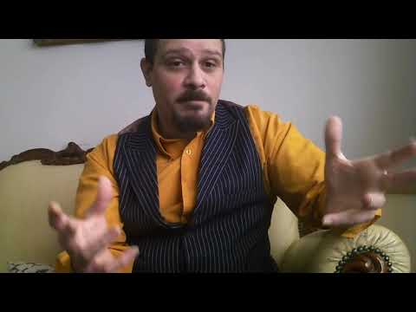 |  | Lord Kozan  Telesales – Management
Profile  Self starter, computer literate and great on the phone (my voice can be found in libraries around the world), I have a multi range set of skills including organizational skills, working with stake holders, project management, handling multiple tasks at the same time, management, marketing understanding and a comprehensive understanding of dealing with CRM systems, Microsoft products and more, with the ability to get the results needed. And I am dedicated to learning and applying.  CONTACT  PHONE NUMBER:  +447777312517  WEBSITE:  https://music.apple.com/us/artist/lord-kozan/1632249192  EMAIL ADDRESS:  kozweb@googlemail.com  HOBBIES  Partying  MC’ing  Reading  Swimming  Travel |  | EDUCATION  QIS  2002  Studied and qualified as a Microsoft Certified Professional (2002)  George Mitchell Secondary School  [Dates from]-1997  Studied and gained GCSE’s in Mathematics, Science, … and all subjects.  WORK EXPERIENCE  Try A Million – Managing Director  2012-current  Project management, tele sales, marketing, organisation, voice talent, production, customer services  Network Resource [Level 1&2 Helpdesk]  2002-2003  Handling client computer issues over the phone  Dial-A-Phone [Outbound Telesales Executive]  2001-2002  Closing sales, CRM, admin, order taking  SKILLS

